**Day 7 - Live Deployment and Post-Launch Practices**

**Environment Variable Configuration for Secure Deployment**

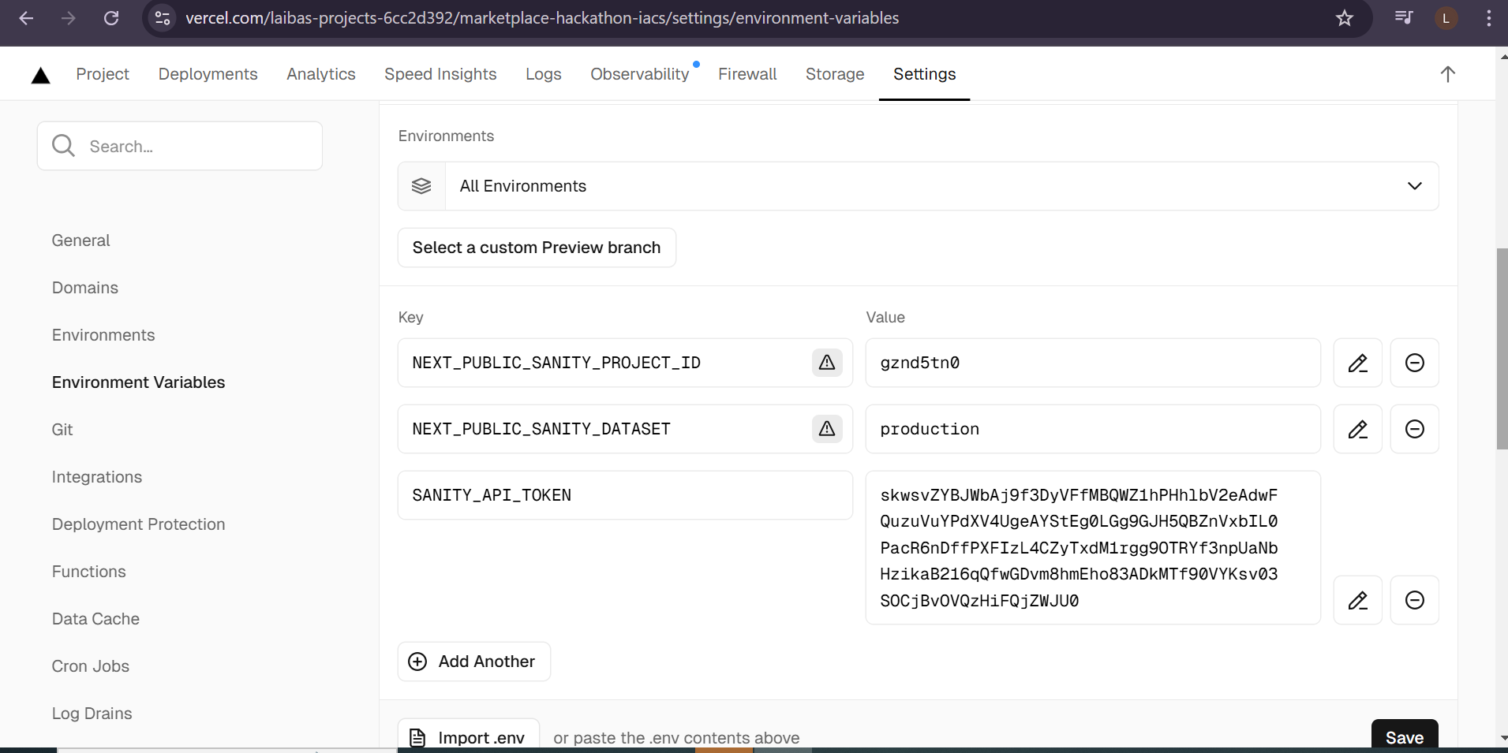

**.SSL and HTTPS Enable**



**Performance optimization**

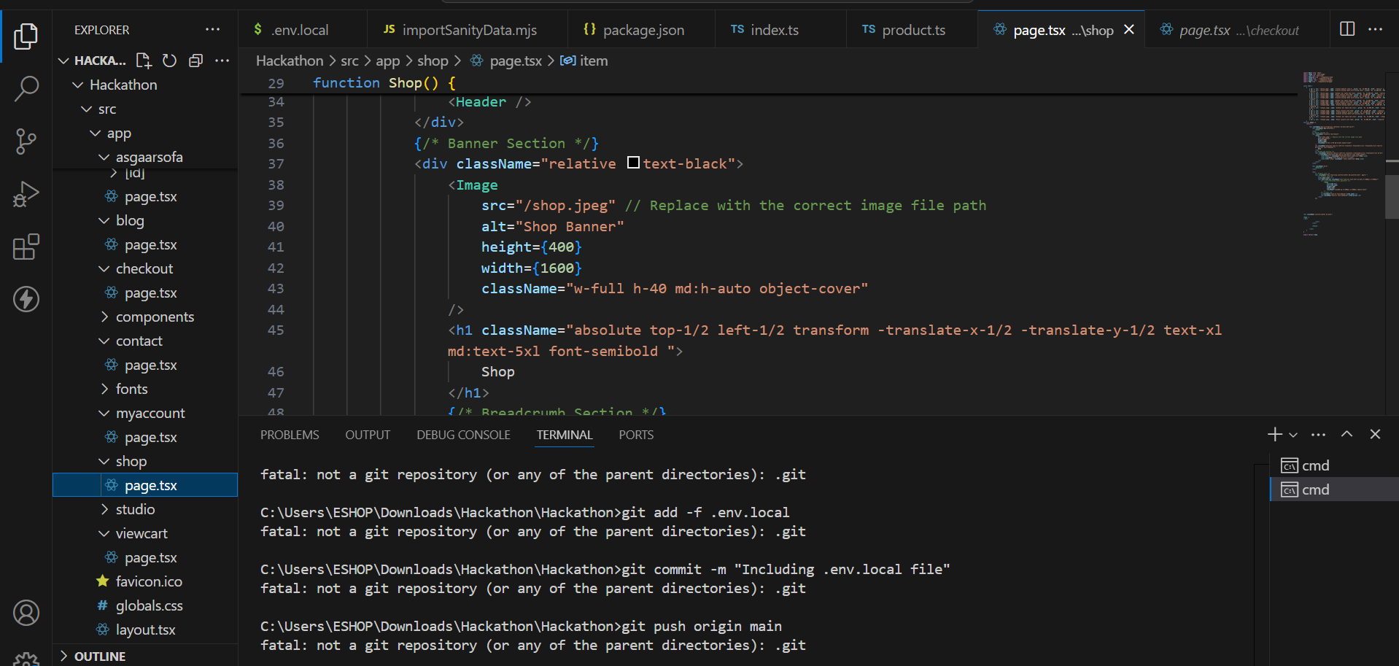

**Monitoring and Analytics Tools**

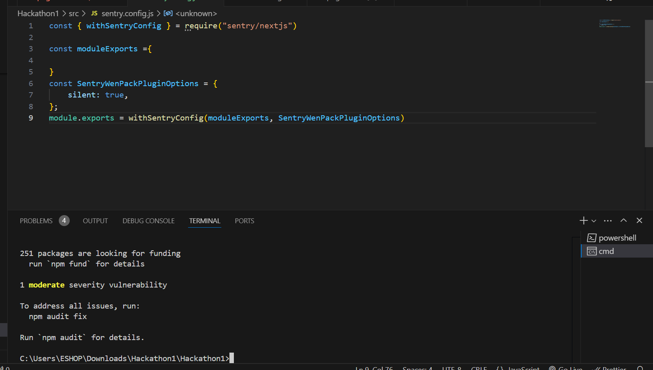

**Backup and Disaster Recovery**

ensures your deployment data is backed up and can be quickly restored in case of failure

**Completed day 7**

This hackathon was an incredible learning experience—I gained new skills and grew so much. I'm now working on enhancing it with better functionality and will soon display it in the marketplace. Stay tuned!